Experiment no.:03 Keerthika.K-241901046
Recover Deleted Files using Forensics Tools
Aim:
To recover deleted files using digital forensic tools by creating a file, deleting it, creating a forensic image, and recovering the deleted file.
Procedure:
- Open Notepad in Windows and create a text file named Malicious.txt with sample content.
- Save the file in a suitable location.
- Right-click the created file and select the Delete option.
- Connect a flash drive or select the appropriate storage device containing the evidence.
- Open FTK Imager and select File → Create Disk Image.
- Choose the appropriate source drive and enter the required case details, evidence number, and examiner name.
- Select the destination directory and provide a name for the image file.
- Start the imaging process and wait until the forensic image is created.
- Open RecoverMyFiles and select the Start Recovery option.
- Choose Recover a Drive and select Add Image to load the forensic image created using FTK Imager.
- Start the file recovery process and wait for the scan to complete.
- Select the File Type tab to categorize the recovered files.
- Choose the appropriate file type, such as TXT, and search for the deleted file.
- Verify whether the deleted file and its contents have been recovered.
Observation:
The experiment demonstrates the process of recovering deleted files using digital forensic tools. A text file was created and deleted, and a forensic image of the storage device was prepared using FTK Imager. The image was then examined using RecoverMyFiles to identify and recover deleted files.
The following observations can be recorded:
- A sample text file was created and saved.
- The file was deleted from its original location.
- A forensic image of the selected storage device was created using FTK Imager.
- The forensic image was loaded into RecoverMyFiles.
- The image was scanned for recoverable files.
- Recovered files were categorized according to their file types.
- The deleted text file was searched for and its recovery status was verified.
Observation Table:
S. No. | Parameter | Observation
1 | File Created | Malicious.txt
2 | Operation | Deleted File Recovery
3 | Imaging Tool | FTK Imager
4 | Recovery Tool | RecoverMyFiles
5 | Evidence Source | Forensic image of the storage device
6 | Recovery Method | Scan the forensic image
7 | File Type | TXT
8 | Recovered File | Record the actual recovery status
9 | Output | Recovered files and their contents, if available
10 | Status | Record the result obtained during the experiment

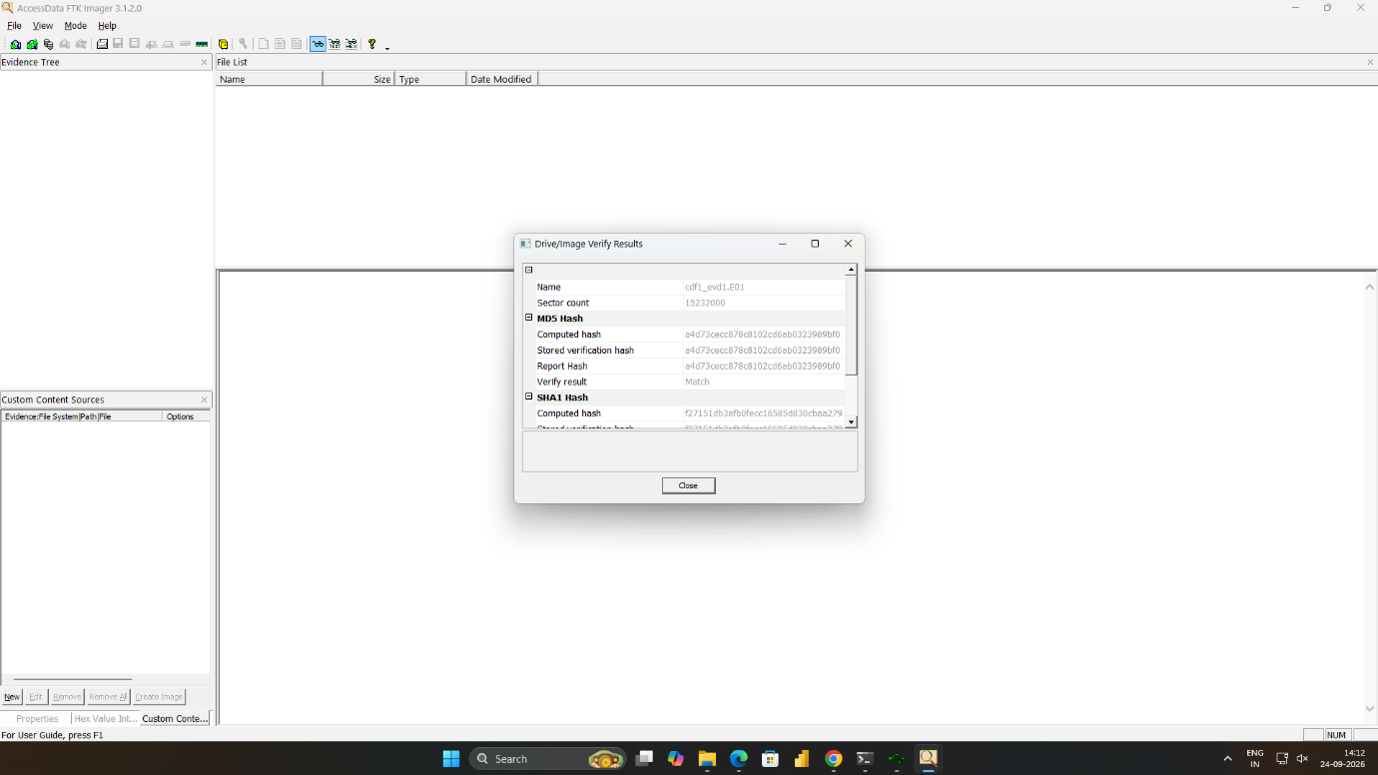

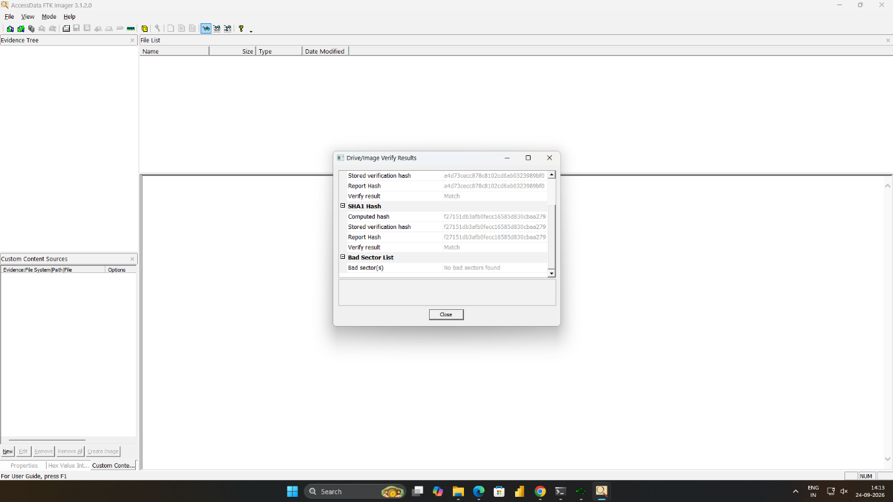



Result:
Thus, the process of recovering deleted files using digital forensic tools was studied. A forensic image was created using FTK Imager and examined using RecoverMyFiles to identify and recover deleted files.

